Brady Heinz 4.2 Assignment 2/8/2026
Before changes
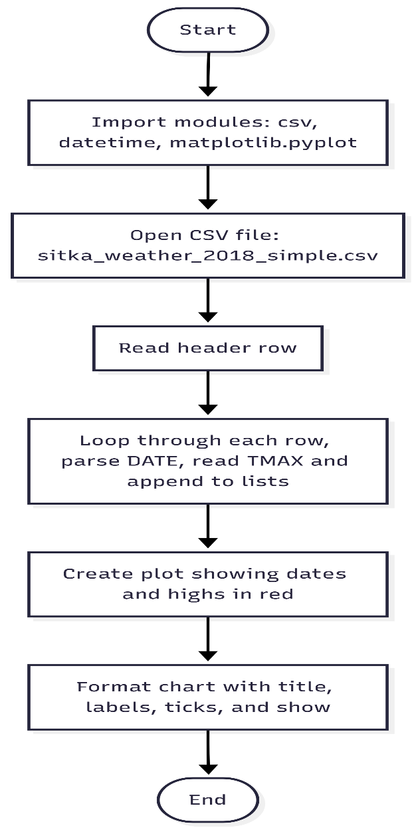

After changes
